
County of San Diego – Health and Human Services Agency (HHSA)
Behavioral Health Services (BHS) – Information Notice
To:  From: | Mental Health Contracted Service Providers  Behavioral Health Services – Quality Management Unit
Date: | August 15, 2022
Title | BHS Plan: CalAIM Documentation Reform Compliance- 8/15/22

The Department of Health Care Services (DHCS) released the final information notice regarding documentation reform, BHIN 22-019 (ca.gov) effective July 1, 2022 which outlines new requirements aiming to improve the beneficiary experience by streamlining and standardizing clinical documentation requirements across Medi-Cal SMHS, DMC, and DMC-ODS services.

DHCS recognizes the complexity and tremendous effort it will take on the part of the counties to implement these updates and ensure that the changes will be made in a thoughtful manner with attention to provider and beneficiary impact. The County of San Diego (County) has developed a systematic roll out of documentation expectations that align with the CalAIM initiatives.

Behavioral Health Assessment: GO LIVE DATE: 7/22/22
With the Cerner Millennium Outpatient module build continuing, and recognition that development of new forms in the current system is not practical, the first phase of roll out for this requirement consisted of the current assessment in Cerner being updated to highlight the Domain requirements. There is a form fill version of this document along with a detailed Explanation Sheet available on Optum for review.

The updated BHA addresses all required Domains as outlined in DHCS’s BHIN 22-019. The questions in the BHA which correspond to the required domain elements identify the specific domain to which the question corresponds (“Domain #”) and are left-justified and in ALL CAPS. Any non-essential questions have been indented and are not capitalized.

Additionally, to align with the spirit of CalAIM initiatives to provide standardized Assessments and reduce redundancy and administrative burden to programs, we have reviewed and consolidated our BHA’s as follows:
• AOA BHA is now being utilized by all AOA Outpatient Programs, START Programs, and Walk-in Clinics.
o START specific BHAs became inactive as of 7/22/22
o Walk-in BHAs became inactive as of 7/22/22
• JFS STAT specific BHAs became inactive; JFS STAT now utilizes the CYF BHA as of 7/22/22
• CSU, ESU, TBS, PERT, and CYF 0-5 – no changes to BHA/screenings utilized.

Timelines:
- Initial Assessments are due no later than 60 days from date of Admission
- Reassessments are to be completed as clinically indicated but no later than 3 years after either the admission date or date of last assessment

The second phase of this roll out will include the System of Care provider representatives to develop an assessment which meets all domain criteria that can be built in the new Cerner Millennium product, using additional formatting functions available to streamline documentation.
The third phase will build the new form in Cerner Millennium for electronic roll out to the System of Care.

Problem List/Client Plan: GO LIVE DATE: 8/26/22
Problem List
A new requirement as part of the CalAIM initiative, is the creation and update of a Problem List. This is a list of symptoms, conditions, diagnoses, and/or risk factors identified through assessment, psychiatric diagnostic evaluation, crisis encounters, or other types of service encounters.

The requirement applies to ALL clients currently open to a program, across ALL service lines. As the current Diagnosis Form will populate into the new Problem List, the program shall ensure the current Diagnosis Form is accurate and up to date, if not program shall make necessary updates. Once the Diagnosis Form is accurate, the program will open a new Assessment titled “Problem List.”
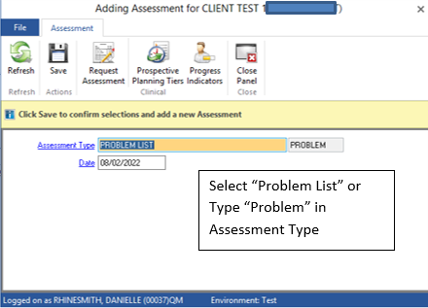
If no Social Determinants of Health Codes are being selected, and there are no additional comments, the individual opening the Problem List can Final Approve with the form having the most updated Diagnoses.
However, if Social Determinant Codes are being added, the individual must include a start date, along with their name and job title. If adding to the comments section, before the comment, the individual shall add the date, program unit/subunit and server ID to ensure accuracy of entry.

When ending a Social Determinant Code, enter the end date, long with the name and job title. 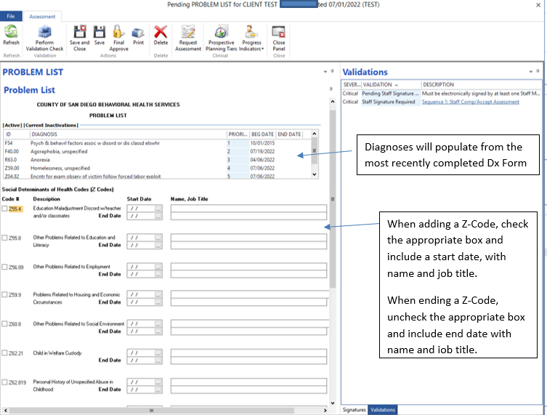
Timelines:
- New Clients:
  - Ideally, initial Problem Lists are created at intake during discussion with client about treatment needs.
  - The Problem List shall be updated on an ongoing basis to reflect the current presentation of the client.
  - Providers shall add or remove problems from the list when there is a relevant change to the client’s condition.
- Existing Clients:
  - All currently open clients will need a Problem List created in CCBH no later than 10/15/22.
  - After initial Problem List is established in CCBH, updates will be on an ongoing basis to reflect the current presentation of the client.
- All Clients:
  - If client is open to another provider, which has an already established Problem List, the new program will not necessarily need to complete a new Problem List.
  - The expectation is that the new program is reviewing the most current Problem List and reviewing with client for accuracy.
    - If no changes are needed, a progress note in CCBH indicating the Problem List was reviewed and remains unchanged is all that is needed
    - If updates are identified, new program will need to make necessary updates.
Client Plans
With the implementation of the Problem List, several programs will no longer be required to complete a Client Plan in the EHR. However, the following service lines are still required to have an active client plan in place in CCBH:
- ICC
- TFC
- TBS
- IHBS
- STRTPs
- Crisis House
For those services that continue to require a client plan, follow the process outlined below:
- Initial Client Plans are due as follows:
  - STRTP due within 10 calendar days
  - ICC, TFC, and IHBS will be due within 60 calendar days
  - TBS due prior to initial coaching session
  - Crisis House due within the first 24 hours of intake
- As of 8/29/22, any open/active client plan in CCBH will remain active with current timelines.
- Once the timelines expire, an updated client plan will need to be completed
  - ICC, TFC, and IHBS will be on 6-month timelines for updates, per UM requirements
  - TBS is on 30-day timeline for updated plans
  - STRTPs are on 90-day timeline for updated plans
  - Crisis Houses will review or update at a minimum every 7 days
- When making the updates to the plan, only the interventions of those services above will need to be noted on the plan.
  - Ex: If client is working on both ICC and individual rehab, only the ICC would need to be captured within the plan.
For those services that no longer require a client plan:
- The current plan in CCBH can be ended with the creation of the Problem List, which is due by 10/15/22, or the program can choose to wait until the plan is expired and then end date the plan.
- Once the Client Plan has been ended the program will need to open a Limited-Service Log to attach progress notes to moving forward.

In order to reduce continued Client Plan requirements, we have adjusted the current Client Plan in CCBH to have less information, see screenshots below:
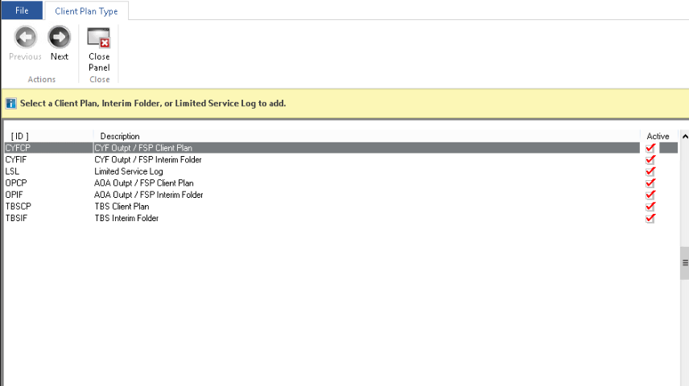
As there are only a select few service lines that require a client plan, the additional families have been removed.

Select the appropriate AOA or CYF plan.

Continue creating the Client Plan as you have in the past. Note once you reach the interventions, only those that require a Client Plan will be available. See screenshots below:
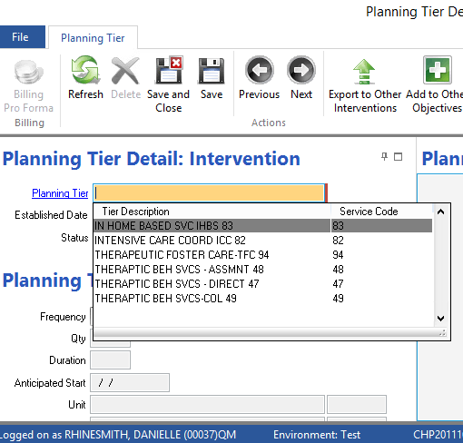

Client Plan Template: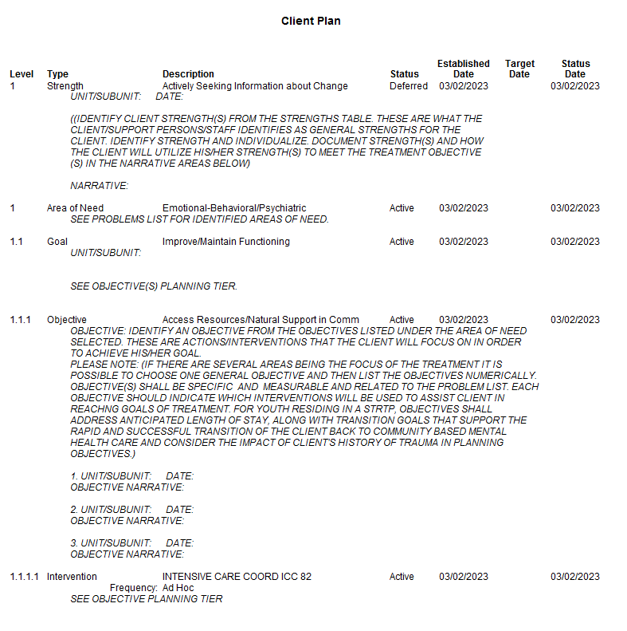
Objective narrative and intervention narrative can be combined here.

When completing your objective, indicate how the intervention will support that.
Only add the intervention that requires a client plan.

No need for a narrative, as this is combined in with the Objective.
When selection Area of Need, choose “Emotional Behavioral/Psychiatric.”

The narrative will pre-populate with “See Problem List for Identified Area of Need.” There is no need for additional information here.
Note that while Case Management and Peer Support services no longer require an active client plan, they do require that a plan of care is outlined in a Progress Note (please see Progress Notes section below for more details).

Progress Notes: GO LIVE DATE: 8/26/22
Progress Note templates have been updated to promote the more streamlined, client relevant documentation of services.

Specifically, there is now one new note type directly related to the CalAIM initiative. It is titled: Case Management/Peer Support Client Plan Note. There are explanation sheets available for these progress notes on the Optum website under the UCRM tab:
https://www.optumsandiego.com/content/SanDiego/sandiego/en/county-staff---providers/orgpublicdocs.html

This note type is to be used solely for the purpose of those programs providing Targeted Case Management and Peer Support Services, specifically for documenting the treatment plan. Once the treatment plan is documented, all other case management and peer support services shall be documented in the Individual Progress Note type using the General Progress note template. See screenshots below:

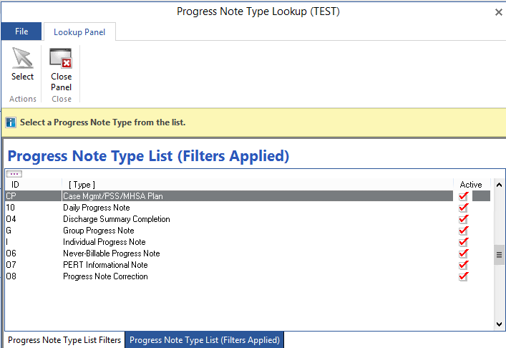
Select the Case Mgmt/PSS/MHSA Plan option

Once this note type is loaded, providers will still be required to choose the template from the drop menu. See screenshots below:
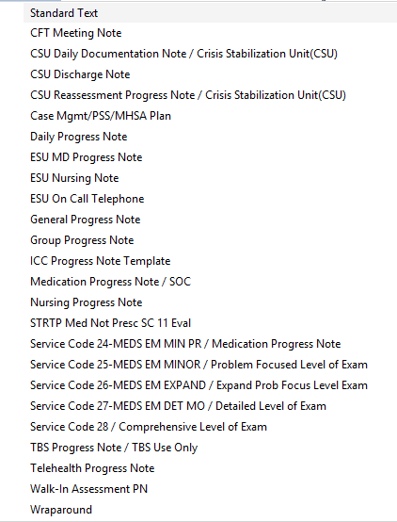
Select the Case Mgmt/PSS/MHSA Plan template from the drop-down menu

Template for Case Mgmt/PSP/MHSA Plan:
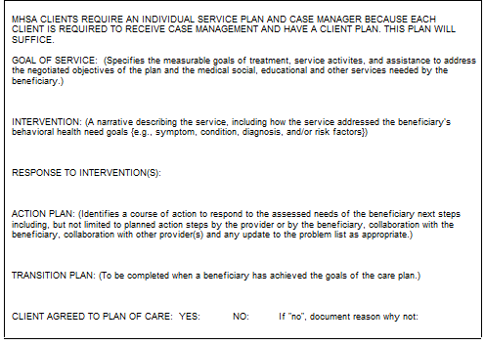

Other services will be documented using the Individual Progress Note type, choosing the appropriate template for the service from the drop down. See screenshots below:
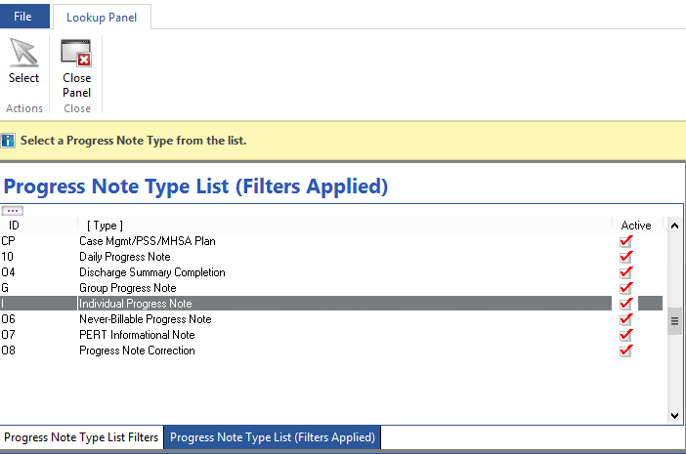
Select the Individual Progress Note Option

Once this note type is loaded, providers will still be required to choose the template from the drop menu. See screenshots below:

Select the General Progress Note template from the drop-down menu

General Progress Note Template

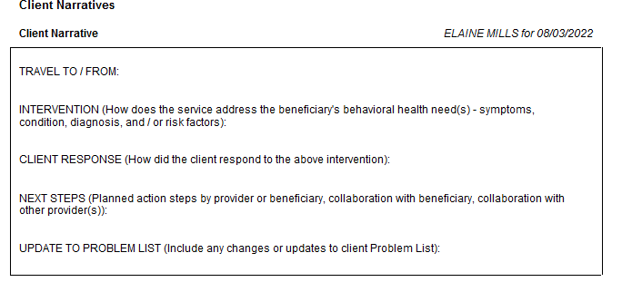
Timelines:
- Progress notes are to be completed within 3 business days, or 24 hours of a crisis service
- Progress notes that require co-signature must be completed and signed by SERVER within 3 business days and must be co-signed in a timely manner
- Progress notes which are not completed within the above timelines are not considered recoupable, however, it will be noted out of Compliance (as a survey question)
- The previous 14-day standard no longer applies to progress notes and no longer requires a disallowance
For More Information:
HHSA, QI Matters: qimatters.hhsa@sdcounty.ca.gov

